Show Me the Money: Forecasting Economic Aid with Machine Learning

Laura H. Kahn
School of Informatics and Computing
Indiana University
Bloomington, IN, USA
email:lkahn@indiana.edu
Majid Khorrami
School of Informatics and Computing
Indiana University
Bloomington, IN, USA
email: mkhorrami@yahoo.com

Abstract— foreign assistance has the potential to promote America’s interests, improves lives abroad and contribute to the United Nation’s Sustainable Development Goals. What if decision makers could use data science techniques to predict an approximation of how much aid they would receive? Countries could plan for the future by knowing how much aid they will receive. Naïve Bayes, Decision Tree, Support Vector Machine and K-Nearest Neighbors machine learning algorithms were used to predict economic aid amount categories using U.S. Agency for International Development historical data. All classifiers outperformed the baseline accuracy by at least 7%

Keywords- unsupervised machine learning; classification; international development; finance forecasting

Introduction
The U.S. Agency for International Development (USAID) is one of the largest government providers of economic aid. There are numerous other government and non-profit organizations that provide foreign aid around the world but USAID was chosen due to its completeness.

Economic aid disbursement amounts from the U.S. Agency for International Development (USAID) from 2014 to 2016 to 176 countries were extracted from explorer.usaid.gov. Economic aid is used for programs with a development or humanitarian objective. In 2014, the total amount included for all countries was US$9.374 billion, $8.434 billion in 2015 and $7.307 billion in 2016.

Countries receiving the highest amount of aid on average for all three years (listed in alphabetical order) include: Afghanistan, Ethiopia, Jordan, Kenya, Nigeria, Pakistan, Syria, South Sudan, Tanzania and South Africa. All of these countries received an average of more than $500 million each of the years.

The hypothesis of whether foreign economic aid disbursement amounts can be predicted was tested using Naïve Bayes, Decision Tree, Support Vector Machine and K-Nearest Neighbors machine learning algorithms. All of the classifiers outperformed the baseline accuracy by at least 7%.

RELATED WORK
Kourtellos et al. examine if there is a linear relationship between international aid and a country’s economic growth [3]. Nyman and Ormerad use random forest machine learning and gross domestic product to forecast economic changes [4]. Abuzeid and many others examine the effectiveness of foreign economic aid in growing economies [2]. To our knowledge, no one has used data science machine learning principles to date to predict future aid amounts.

DATA PREPARATION

Ethics Statement
The data analyzed are publically available from an open source (https://explorer.usaid.gov/data.html). Since the data contains economic dispersion amounts at a country level and has been aggregated, there is no private data contained within it. For more information on the data collection ethic policies of USAID, see [8]. The authors have no affiliation with USAID but are users of their data.

Extraction
USAID economic and military aid data was available by country for download as a CSV file. The original file contained over 42,000 rows of data from 1947 – 2016 (21,000+ rows of Military Aid and 21,000+ rows of Economic Aid). The final dataset included Economic Aid disbursement amounts for 2014-2016 for each of 176 countries. There are 19 countries that are not included in the dataset and therefore do not receive any economic aid from USAID. The three most recent years were chosen for analysis to try to minimize the effect of historical events on the data.

The final dataset included the following columns extracted from the complete file: ‘country_name’, ‘assistance_category_name’, ‘fiscal_year’, and ‘current_amount.’ About 40 other attributes were removed from the source file.

Actual aid amounts (aka ‘disbursed’) rather than ‘obligated’ aid amounts were chosen for our classifiers since they represent the US dollars actually given to the countries. Other features that affect economic aid such as Gross Domestic Product annual percent growth data from the World Bank (http://data.worldbank.org/data-catalog/world-development-indicators) were originally considered for the analysis but were removed.

Pre-Processing
All 176 countries had data for at least two of the three years during the studied time period of 2014-2016. Thirty seven countries were missing a value for one of the years. The missing values were assumed to be independent of their features and to occur at random. In order to avoid having a reduced model that would exclude countries, the missing value was replaced with a calculation of the average of the two existing values in a manner similar to work by Saar-Tsechansky. The Pandas library within Python 3.5 was used to convert the data into a dataframe for processing.

Features
Initial research included aid amount for 2014 and 2015 as the feature for each of the 176 countries.

The final data set had three features: aid amount for 2014, aid amount for 2015 and aid amount for 2016 for 176 countries. There were a total of 528 observations in the data set. The problem-solving principle of Occam’s razor [5] was considered when choosing the aid amounts as the features in the models in hopes to use the simplest model to make the most accurate predictions.

Exploratory Data Analysis
After further data exploration, we noticed the aid amounts varied substantially from year to year. Twenty percent of the countries (36) that received economic aid in 2015 received no economic aid in 2016. Eighty-one percent (143) countries had aid amounts decrease by more than 15% in 2016. According to the World Bank’s calculations, aid remittance to developing countries decreased by 2% cumulatively in 2016 [7]. It is possible that a similar trend in decreased aid in 2016 could have also happened at USAID. A domain expert would be needed for possible explanations.
Summary statistics were performed to examine the standard deviation of the aid amounts for each year as shown in Table 1.
- Summary statistics for aid totals
 | 2014 | 2015 | 2016
Count | 1.350 e+02 | 1.350 e+02 | 1.350 e+02
Mean | 1.315 e+08 | 1.379 e+08 | 9.006 e+07
Std | 2.497 e+08 | 2.667 e+08 | 1.668 e+08
Min | 3.098 e+03 | 1.439 e+04 | -1.088 e+05
25% | 7.249 e+06 | 8.346 e+06 | 1.434 e+06
50% | 4.079 e+07 | 3.933 e+07 | 2.045 e+07
75% | 1.382 e+08 | 1.312 e+08 | 1.206 e+08
Max | 2.203 e+09 | 2.224 e+09 | 1.263 e+09

Data assumptions
Understanding why certain countries receive different amounts of economic aids or why the amounts vary yearly is beyond the scope of this analysis.

In order to assist policy makers at a country level for future predictions, the data granularity was examined for each country.

Looking at this subset of data presents a snapshot of economic aid disbursements at a moment in time but does not disclose the entire socio, economic or political implications of the use of economic aid and its effectiveness around the world.

Methods
Initially aid amounts for 2014 and 2015 were used as the features /independent variables to see if aid amount for 2016 (the target) could be predicted. Cross validation within the Sci-kit learn Python library was used to avoid overfitting or underfitting of the machine learning models in a manner similar to work by Abraham.
A linear regression was tested but the aid values were too varied from 2014 to 2015 and between countries to predict the exact dollar amount with any accuracy. Since the accuracy of this model was 0, the focus of the analysis was changed from predicting the exact dollar amount to predicting amount category using historical data.
The aid data was manually encoded with one of the six category labels: Micro (< $5 million), Small ($5 – $20 million), Medium ($20 - $50 million), Large ($50 -$100 million), XL ($100 - $200 million) and Substantial (> $200 million).
Each category was encoded with a value of 1 – 6: Micro = 1, Small = 2, Medium = 3, Large = 4, XL = 5 and Substantial = 6.
In addition to performing summary statistics by year, the distribution of the aid by category was also examined.
Figure 1 Economic Aid Category Distribution by Year
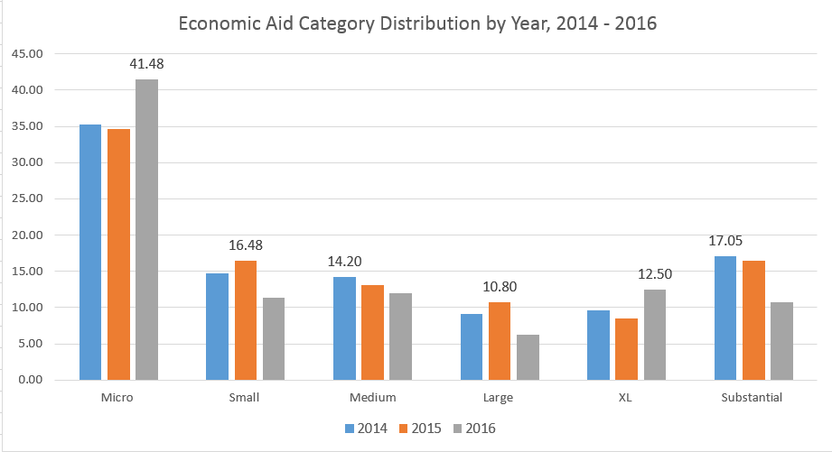
Over half of the economic aid from 2014-2016 fell into one of two categories: “Micro” (less than $5 million) or “Substantial” (more than $40 million). The Micro category has a maximum of 41.48% of in 2016 while only a maximum of 17.05% fell into the Substantial category of over $200 million in 2014. The distribution into the other categories of Small, Medium, Large and XL varied from year to year but remained less than 20% of the total distribution.

Machine learning models predict the output of new data based on past data. Selecting relevant features and choosing how to encode them helps to extract a good model. Naïve Bayes, Decision Tree, Support Vector Machine and
K-Nearest Neighbors machine learning algorithms were used to predict amount categories. Aid amount was chosen as the feature.

An 80/20 training and test data split and a 10-fold cross validation were used to optimize the model’s performance.

Results
There were 9 countries, or about 5.1% of the countries where classifiers didn’t predict aid category for any of the years, including Benin, Bolivia, Guinea, Mexico, Mongolia, Namibia, Pakistan, Russia and Sierra Leone. For these countries, the average amount difference between minimum and maximum disbursement was $109.8 million. The reason behind the large differences in disbursement amounts in these years are unknown.
A baseline accuracy was calculated by looking at the highest number of correct predictions for all of the years 2014 – 2016 (104 / 176) and was 59.1%. K-Nearest Neighbors had the highest accuracy of 93.18%, followed by Support Vector Machine (92.04%) and then Decision Tree and Naïve Bayes (90.91%). All of the classifiers outperformed the baseline by at least 31.81%., which is a significant improvement. This result supports the hypothesis that future economic aid amount categories (not exact values) can be predicted by country using historical data.
The accuracy results are somewhat surprising based on the variation in the data between countries as shown in Table 1.
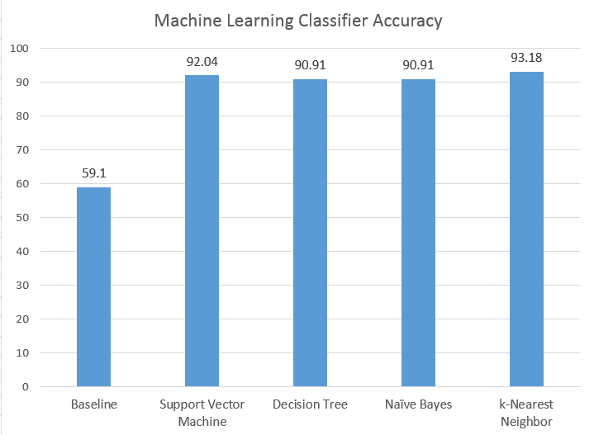

Figure 2 Machine Learning Classifier Accuracy

conclusion
Machine learning algorithms using historical data were successfully used to predict what category amount of aid would probably be received in the future. For instance, using the principles discussed in the methods section, a country could know from year to year if they were going to probably receive a ‘Micro’, ‘Small’, ‘Medium’, ‘Large’, ‘XL’ or ‘Substantial’ amount of economic aid from USAID.
This research has significant potential for decision and policy makers at a country level. Having a quantified way to understand the aid amount category they will most likely receive leads to more certainty for planning purposes.
This research is also significant since it is the first known time machine learning data science principles have been used in the field of economic aid data for international development. It could be used with other aid providers such as nonprofits to get a more quantified description of the aid landscape.
Future research topics could also include the use of other features in the models such as Gross Domestic Product change, water resource indicators, transportation indicators, population density and other factors with the input of domain experts.
Including additional data as far back as 1947 could also potentially provide some interesting insights.
An interesting question for future analysis could be how the machine learning models perform from 1947 to present using data from the country against itself.
Furthermore, additional research into using other types of machine learning classifiers may yield different results.

Acknowledgment
The authors would like to acknowledge experts at USAID for providing the suggestion to focus on economic aid amounts. The authors would also like to thank two anonymous reviewers for editing assistance.

REFERENCES

- Abraham, A., F. Pedregosa, M.Eickenburg, P. Gervais, A. Mueller, J. Kossaifi, A. Gramfort, B. Thirion and G. Varoquaux. Machine learning for neuroimaging with scikit-learn. Neuroinform., 21 February 2014. https://doi.org/10.3389/fninf.2014.00014
- Abuzeid, Farah. Foreign Aid and the “Big Push” Theory: Lessons from Sub-Saharan Africa. Stanford Journal of International Relations. Vol. XI, No 1, pp. 16-23.

- Kourtellos, A. C. Ming Tan, and X. Zhang. Is the Relationship Between Aid and Economic Growth Nonlinear? International Food Policy Research Institute, Discussion Paper 00694, http://ageconsearch.umn.edu/bitstream/42557/2/ifpridp00694.pdf. March 2007. (Accessed 25 August 2017).
- Nyman R. and P. Omerod. Predicting Economic Recessions Using Machine Learning Algorithms. https://arxiv.org/ftp/arxiv/papers/1701/1701.01428.pdf.
- Occam’s razor. Wikipedia article. https://en.wikipedia.org/wiki/Occam%27s_razor. (Accessed 14 August 2017).
- Saar-Tsechansky, M. Handling Missing Values when Applying Classification Models. Journal of Machine Learning Research 8 (2007): I625-I657, 2007.
- Trends in Migration and Remittances 2017. World Bank Infographic: http://www.worldbank.org/en/news/infographic/2017/04/21/trends-in-migration-and-remittances-2017 (Accessed 14 May 2017).
- USAID Research Policy 2016. https://www.usaid.gov/sites/default/files/documents/15396/USAID%20Scientific%20Research%20Policy%2012-3-14.pdf (Accessed 25 August 2017)

